Hwk 1

Used excel to help with solving formulas and creating graphs along with hand checking some calculations

## Problem #1

1. Answers
   1. Sample Size: 24
   2. Histogram
      1. 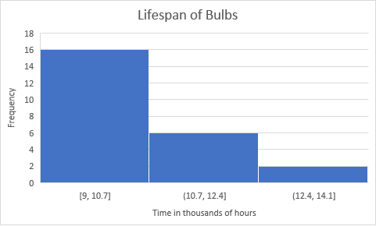
   3. Mean: 10.292
   4. Median: 9.8
   5. Sample variance: 1.89
   6. Sample Std. Deviation: 1.37
2. How I solved it and Formulas used
   1. Nothing extra, simply counted the amount of numbers
   2. Width is 1.7, I let excel make the chart
   3. Added all the values and divided by 24
      1. 9+9+9+9+9.1+9.1+9.1+9.1+9.2+9.3+9.5+9.6+10+10.1+10.5+10.7+11+11.1+11.4+11.6+12+12.2+13.1+13.3=247
      2. 247/24 = 10.292
   4. Sorted the data from smallest to largest, took average of 9.6 and 10 since there’s an even number of sample data
      1. 9.6+10 = 19.6
      2. 19.6/2 = 9.8
   5. Used VAR.S function in excel, by hand or in steps would’ve been found by getting the difference in the data and average, square that, then taking the average of that with the total data points being minus 1
   6. Took the square root of the Sample Variance, could have also used STDEV.S

## Problem 2

1. Answers
   1. Created in Excel
   2. Created in Excel, Key 1 | 0 = 1.0

* 1. Created in Excel, Key 1 |1 = 11

* 1. Rural Samples:
     1. Average: 7.82
        1. Used excel function AVERAGE
     2. Std. Deviation: 6.17
        1. Used STDEV.S, could have also done square root of VAR.S function in excel or by hand/in steps would’ve been found by getting the difference in the data and average, square that, then taking the average of that with the total data points being minus 1, then took the square root
  2. Urban Samples:
     1. Average: 39.07
        1. Used excel function AVERAGE
     2. Std. Deviation: 40.94
        1. Used STDEV.S excel function, as said previously for Rural Samples could’ve also been calculated in other ways